National College of Ireland
MSc in Web Technologies
2013/2014

Maire Kavanagh
Student ID x13117785
maire.kavanagh@student.ncirl.com

‘
Deployment Project Report



Contents

Introduction 4

Specification of the Delivery process 4
User requirements 4
Function requirements 7
Use case for Process Trigger 5
Use case for Monitor 5
Use case for Process debug 6
Use case of generate report 6
Use case of back up database 6
Risks and Controls 9
Design of Delivery process 10
Detailed design 10
Process Flow 10
Architecture 10
Build process 10
Build Sub Functions 11
Integration process 11
Integration Sub Functions 11
Test process 11
Test Sub functions 11
Deployment process 12
Deployment sub functions 12
Monitoring process 12
Monitoring sub functions 12
Test Plan 13
Unit tests 13
Integration testing 15
End user testing 15
Execution plan 16
Record of demonstration 18
Summary and Conclusions 23
Appendix A : Development Processes – Waterfall and Agile 24
Appendix B - ITIL – how the project elements fit in… 25
Appendix C – Alert email to Adminstrator 26
Appendix D – Logging 27
Appendix E – Database Back-up 28
Appendix F : Printout of rbitdmk.sh ..29
Appendix G : Printout of rcldmk.sh 31

Introduction
The purpose of the project is to design and implement a delivery process to manage the build integration, test, deployment and monitoring of a web site.
Ultimately it should be possible to have a system where following a change in content of the website this process will be triggered, so that in a company environment, the new software can be ‘rolled out’ to one or many users in a safe, controlled manner.

Specification of the Delivery process
The first part of the process is to define the process requirements. A business technique - MoSCoW -will be used which helps to prioritise requirements by stating them in plain English so that they can be understood and discussed by all stakeholders. After review that will be grouped into categories High Medium and Low priority defined as follows:
- M - MUST: Describes a requirement that must be satisfied in the final solution for the solution to be considered a success.
- S - SHOULD: Represents a high-priority item that should be included in the solution if it is possible. This is often a critical requirement but one which can be satisfied in other ways if strictly necessary.
- C - COULD: Describes a requirement which is considered desirable but not necessary. This will be included if time and resources permit.
- W - WON'T: Represents a requirement that stakeholders have agreed will not be implemented in a given release, but may be considered for the future. (note: occasionally the word "Would" is substituted for "Won't" to give a clearer understanding of this choice)
Adherence to MoSoCow - Must have, Could Have, Should Have – ensure that while all requirements are important, they are prioritised so that developers will initially try to deliver all the M, S and C requirements but the S and C requirements will be the first to go if the delivery timescale looks threatened.

User requirements
No. | MoSoCo | Statement
1 | Mo | It must be possible to deploy the new software with a single command.
2 | Mo | The software must not be loaded if it does not pass the tests in the deployment process. In the event, the ‘old’ software must be restored so that it is in place at the end of the trial.
3 | Mo | It must be possible to view error logs.
4 | So | Error logging should be in one place
5 | So | Major errors should initiate a notification email to the Administrator
6. | So | Database should be backed up at set intervals e.g. daily or weekly
7. | Wo | Reports for Management the company logo prominently displayed on them.

Use Cases
Use Cases for how an operator of the Deployment Process can
- Trigger the process to start
- Monitor the process
- Debug the process
- Generate reports from the process
- Back up database

Use case for Process Trigger

Use Case Name: | Process Trigger
ID: | UC01
Summary: | The user runs a script to load the new code in a protected area (sandbox). The script first creates the sandbox, copies and extracts the files. The user checks on screen for errors.
Actor: | User.
Precondition: | The software has been released to the deployment process at a new revision level and is now available in github.
Basic flow of events: | - The user enters terminal command to run the bash script.  - Bash script creates a Sandbox.  - Bash script pulls repository from github, loads to Sandbox and extracts files.
Exceptions: | If there is an error, the process will be halted.
Post Condition: | If the use case is successful, the deployment process will move to the next stage.

Use case for Monitor
Use Case Name: | Monitor
ID: | UC02
Summary: | The user initiates a logging system to record errors as should they occur. A facility to alert nominated users by email is included.
Actor: | User.
Precondition: | The deployment scripts are set up to append errors to the log file.
Basic flow of events: | - User enters terminal command to run crontab.  - Crontab report at regular intervals any errors that may occur  - Email alerts are sent out to the user or other nominated individual.
Exceptions: | If the user has a code error, the process will echo the occurrence of an error and the process will not be executed.
Post Condition: | This is an ongoing process to check the correct operation and performance of the site

Use case for Process debug
Use Case Name: | Process debug
ID: | UC03
Summary: | Stop points are included in the scripts that can be invoked in a debug mode to allow the user to make checks and identify the problem cause.
Actor: | User.
Precondition: | A script has been identified as failing
Basic flow of events: | - User runs script selecting a debug option  - User analyses system status at stop points  - User identifies issue
Exceptions: | Errors not identified as potential issues may require a redesign of this code
Post Condition: | This is an recursive process that it continues until all errors are eliminated.

Use case of generate report
Use Case Name: | Generate Report
ID: | UC04
Summary: | The user executes a script to generate a suitably formatted report
Actor: | User.
Precondition: | The user must execute the execution
Basic flow of events: | - User enters terminal command to run the bash script  - Readable reports generated.
Exceptions:
Post Condition: | The user circulates the report to stakeholders

Use case of back-up data base
Use Case Name: | Backup Database
ID: | UC05
Summary: | The user executes a script to generate a back-up database.
Actor: | User.
Precondition: | The user must execute the execution
Basic flow of events: | - User enters terminal command to run the backup  - Database backup is generated.  - Report backup activity using crontab
Exceptions: | If mysql is down, this will not be executed
Post Condition: | The backup database can be retrieved in the event the original gets corrupted.

Function requirements
It must be possible to deploy the new software with a single command.
The software must not be loaded if it does not pass the tests in the deployment process. In the event, the ‘old’ software must be restored so that it is in place at the end of the trial.
It must be possible to view error logs.
Error logging is to be in one place
Major errors are to initiate a notification email to the Administrator
Database is to be backed up at set intervals e.g. daily or weekly

Delivery process
[Before getting into the detail of the delivery process, the general approach is discussed. It is proposed to use the V-model for the SDLC - Systems Development Life Cycle in this design and to promote the ITIL standards, including the Release and Deployment model, for the safe introduction of new software.
The V model is generally considered a useful model for small to medium sized projects where requirements are clearly defined and fixed. It does not cater well for projects where requirements are likely to change as this results is a lot of rewriting of documentation. While the original application development project may have followed the full V model, the small V model adequately covers a deployment project such as this.
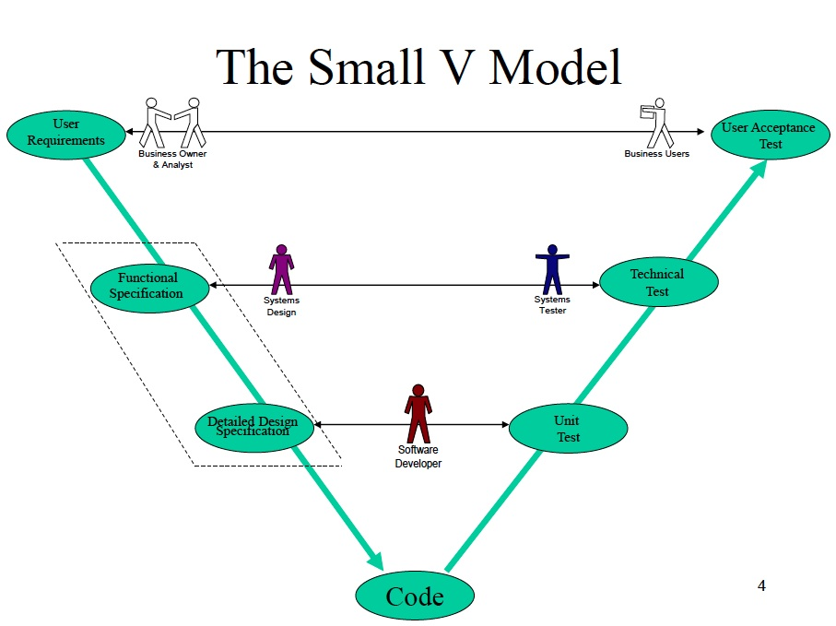

The main approach of the V model is that the development consists of pairs of definition and verification steps (the descending and the ascending line of the V), with the implementation cycle in the middle. It starts with requirement analysis and the creation of the Requirement Specification, followed by the Functional Specification and finally the detailed Design Specification. As the code comes together, unit tests are carried out first, then the integration tests and finally the system verification and validation. Each step is followed by a peer review, thus ensuring that the development goes on the right direction. In well-defined projects the V model can minimize the project risks, can assure quality, and can reduce the costs on the project life.

While the V model has a linear flow similar to the Waterfall method, it has more scope to incorporate change. The bidirectional horizontal arrows indicate that there is communication between parties at all stages. The tests are prepared while the code is being written which can uncover any ambiguities in the specifications, and as the tests are carried out, should they fail, this information is fed back to the design team who may correct the code or in some cases change the specification.

An alternative approach commonly used in software development is the Agile methodology.
Agile is one of a number of iterative development process models. According to Jolote 2005, the basic idea of these models “ is that software should be developed in increments – each increment adding some functional capability to the system until the full system is implemented”. There are other practices associated with Agile where daily meetings are held in ‘scrums’ where both management and developers at all levels get together to review progress, identify where there are problems and take steps to resolve them immediately. Progress is measured in terms of the delivered functionality as a percentage of the overall functionality specified for the project. This measurement is updated regularly so that the team are aware of progress against the final working system. See also Appendix A for further reference.

ITIL (The Information Technology Infrastructure Library) is a framework of practices – now recognised as ‘Best Practice’ on aligning IT services with the needs of a business. It outlines a comprehensive set of management procedure to support organisations in achieving both value and quality in IT operations. The procedures are not organisation specific and cover the three main stages of any service – Service Design, Service Transition and Service Operation. Release and Deployment management fits into the Service Transition stage covering the planning of the rollout of software in addition to designing and implementing procedures for the roll-out of software.

It focuses on the protection of the live environment and its services by having controls and procedures in relation to the deployment of new software.

Risks and Controls
In any project there are risks. It is important to identify risks, and assess their potential impact on the project. Risk management is a proactive process to recognise and manage internal events and external threats that may affect the likelihood of project success. Firstly risks must be identified. This may be done by holding brainstorming sessions involving all project stake holders. Any information on earlier projects should be reviewed and in particular any results of root cause analysis, ensuring any corrective actions have been captured and incorporated into the procedures to be used in this new project.
Once identified, the risks are rated according to their potential impact on the project. They may also be further assessed based on how likely they are to occur, and the resulting impact of the project. This helps quantify the appropriate level of resource that should be allocated to mitigate against each risk.
Each risk has an owner and an action plan to cover the implementation of the controls required.
Throughout the project, and in particular at every release stage, the risk register/action plan is reviewed and may be added to.

No. | Impact | Risk Statement | Control
1 | High | Corrupted content could replace valid working content on the live platform | Content is backed up prior to deployment of new content. If the deployment fails, the old site is kept in place.
2 | High | A data base could get corrupted | A script is to be developed to back up the Database. This can be run periodically using crontab.

Design of Delivery process

Detailed design

Process Flow


Architecture

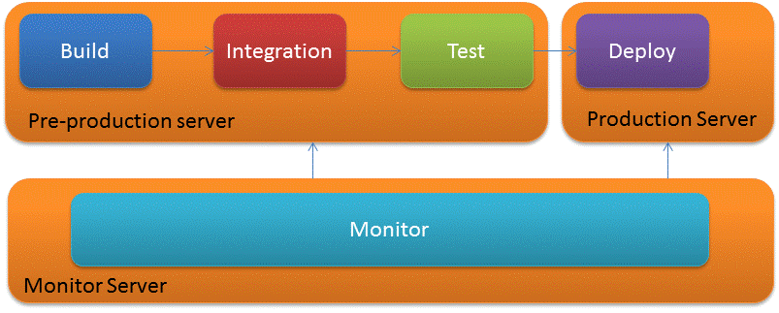

Build process
The build process is initiated by a release of a new build of software which must have been formally reviewed and released to Production. Normally a copy of this released software is put onto a repository – for instance Github - from which it can be downloaded as the input code to the deployment process – the process to roll out the new software.
By taking this code the build process makes sure that the environment is ‘clean’ and revisions of necessary components are at the right level. Everything used in the process must be at a known traceable level. If MySQL is used, this must be at a known software revision. The safest way to do that is to uninstall the software and install again from a known source – defined in the released software.
As an extra precaution, software is held in a ‘Sandbox’ – a separate area to contain the code until it is verified to be defect free. This would protect other users or other environments – such as the production server from any misoperation within the new code.

Build Sub Functions
Create local sandbox
Download from Github
Check Dependencies
Create zip/tar file (package)
Move package to next step
Clean-up
Report/Log

Integration process
Integration integrates the static content with the components that provide the dynamic content, so as to create the overall content

Integration Sub Functions
Create local sandbox
Unpack package
Check Dependencies
Integrate
Create zip/tar file (package)
Move package to next step
Clean-up
Report/Log

Test process
The test process makes sure that the static content is properly constructed and that the dynamic content functions as required.

Test Sub functions
Create local sandbox
Unpack package
Check Dependencies
Perform tests
Create zip/tar file (package)
Move package to next step
Clean-up
Report/Log

Deployment process
Deployment ensures that all components (content, packages etc) and resources (memory, disk, I/O etc) are in place for production. It unpacks the content and move it to its proper location on the production server.
It backs up the content prior to deployment of new content. If the deployment fails, the old site is kept in place.

Deployment sub functions
Create local sandbox
Unpack package
Check Dependencies
Perform tests
Backup current files
Move files
Modify permissions and ownerships
Roll back if necessary
Checksum function to check for changes in files etc.

Monitoring process
Monitoring ensures that the site is functioning from a HTML, HTTP and other socket layer perspective. It should make sure that 6 key parameters (e.g. memory, I/O etc ) are within thresholds. It should report errors.

Monitoring sub functions
Check mysql port
Check http port
Check disk space
Check memory
Check Network availability
Check Network utilisation

Test Plan
The validation phases in the V-Model are:
- Unit Testing: Unit tests which were designed in the module design phase are executed on the code during this validation phase. Unit testing is the testing at code level and helps eliminate bugs at an early stage. Thorough testing here means that fewer problems are likely to be found at a later stage. It is easier to debug problems at this level as a smaller amount of code is under scrutiny for any given problem.
- Integration Testing: Integration testing is to ensure that modules verified to be working at unit test level, continue to work when put together,
- System / Acceptance Testing: Acceptance testing is associated with the business requirement analysis phase and involves testing the product in user environment. Acceptance tests uncover the compatibility issues with the other systems available in the user environment. When developed to its full potential, it also uncovers the non functional issues such as load and performance defects in the actual user environment.

Unit tests
Unit tests verify that the building blocks of the code work individually so that later in the process these verified blocks can be put together to give the required end user functionality.
An example of a unit test here is the code to ensure that Apache is running and if it is not to write to alert those monitoring the system that there is an issue.
(extract from unit_test_apache.sh)
______________________
ERRORCOUNT=0 # reset error counter.
# Functional Body of monitoring script <----------------------------
isApacheRunning
if [ "$?" -eq 1 ]; then
echo Apache process is Running
else
echo Apache process is not Running
ERRORCOUNT=$((ERRORCOUNT+1))
fi

isApacheListening
if [ "$?" -eq 1 ]; then
echo Apache is Listening
# a message is sent to the monitor log to confirm the service is up.
echo "Apache is Listening at Date/Time --> $TIMESTAMP "
echo "Apache process is Running At Date/Time -> $TIMESTAMP" >> log.log
# otherwise an error is flagged to be dealt with at the end of this test sequence
else
echo Apache is not Listening
ERRORCOUNT=$((ERRORCOUNT+1))
fi

isApacheRemoteUp
if [ "$?" -eq 1 ]; then
echo Remote Apache TCP port is up
else
echo Remote Apache TCP port is down
ERRORCOUNT=$((ERRORCOUNT+1))
Fi

# At the end of this test run, if the error counter has been incremented an email message it sent to the Administrator.
if [ $ERRORCOUNT -gt 0 ]
then
echo "There is a problem with Apache" | ruby mail.rb $ADMINISTRATOR $MAILSERVER
fi

The tester will then check that the program responds correctly in the event of a fail scenario. So the Apache server will be turned off to check that it detects the fail mode and sends out an error.

Integration testing
An example of this would be to check Apache and MySQL are running and then enter a record into the database, then to retrieve that record at the end of the test.

System Test / End user testing
At this stage the tests must be extended to ensure that the system works under all conditions. For instance that the database can be read, records can be retrieved, edited and that errors such as the server going down are dealt with appropriately – i.e. the system does not crash but exits the program having sent alerts and to the nominated users such as the Administrator. If there are several users allowed on the system, then it would need to be tested for a comprehensive set of scenarios to give an assurance that an error will not occur if for instance two people try to log into the database at the same time. Basically the tests should cover instances of all likely scenarios that the system must deliver on.
During this phase additional checks resources usage are carried out to ensure that the system is not likely to run out of resource during the specified usage.
System testing can extend to environmental testing where the system is subjected to extremes of temperature and humidity as defined in the system specifications.
CODE
The main files for the project are in the zipped folder under mainfiles –directory and are
Build Integrate Test and Deploy
rfbidtmk.sh
and
Clean Full Deploy
rcfdmk.sh

They are commented to show understanding of the code and a printouts are in Appendices F and G.

Execution Plan
Step | Topic | Verification  Yes/No
1 | Clear Environment
2 | Run Deployment scripting
3 | Demonstrate static content is delivered through browser
4 | Demonstrate dynamic content is delivered through browser
5 | Demonstrate Logging is functioning correctly
6 | Run Deployment scripting again
7 | Demonstrate Content is delivered correctly and logging is functioning correctly
8 | Stop web server, verify logging of event in log
9 | Stop Database, verify logging of event in log
10 | Start web server, verify logging of event in log
11 | Start Database, verify logging of event in log
12 | Change the content in code repository. Run the deployment scripting. Verify that Content is delivered correctly and logging is functioning correctly.

Set up :
using Virtualbox Ubuntu 12.04
Settings: Two rules for port forwarding need to be set up:
Rule 1 – protocol TCP Host IP 127.0.0.1 Host Port 2222 Guest Port 22
Rule 2 – protocol TCP Host IP 127.0.0.1 Host Port 8089 Guest Port 80

Procedure
Run fbitdmk.sh
- If there are no errors, Step 1 has passed.
- Run fdeploy.sh
- If there are no errors, Step 2 has passed.
- On the browser look at 127.0.0.1
- If it shows on the page ‘It works! , Step 3 has passed.
- On the browser look at 127.0.0.1/form.html
- Enter a new name.
- If it enters the name to the database, Step 4 has passed.
- Look at logs – log.log.
- If it shows that mySQL is running – check timestamp, Step 5 has passed.
- Run fdeploy.sh
- If there are no errors, Step 6 has passed.
- Recheck for web pages and logs as above. If the results are the same, Step 7 has passed.
- Run stopmysql.sh – check log. If it shows mysql has stopped, Step 8 has passed.
- Run stopApache.sh – check log. If it shows Apache has stopped, Step 9 has passed.
- Run startmysql.sh – check log. If it shows mysql has started again, Step 10 has passed.
- Run startApache.sh – check log. If it shows Apache has started again, Step 11 has passed.
- Run Test12 which adds a new html page. On the browser look at 127.0.0.1/test12.html
If it shows a picture of a bird, this is new content. Also check content and logging again.
If these tests behave as expected, Step 12 has passed.

Record of demonstration
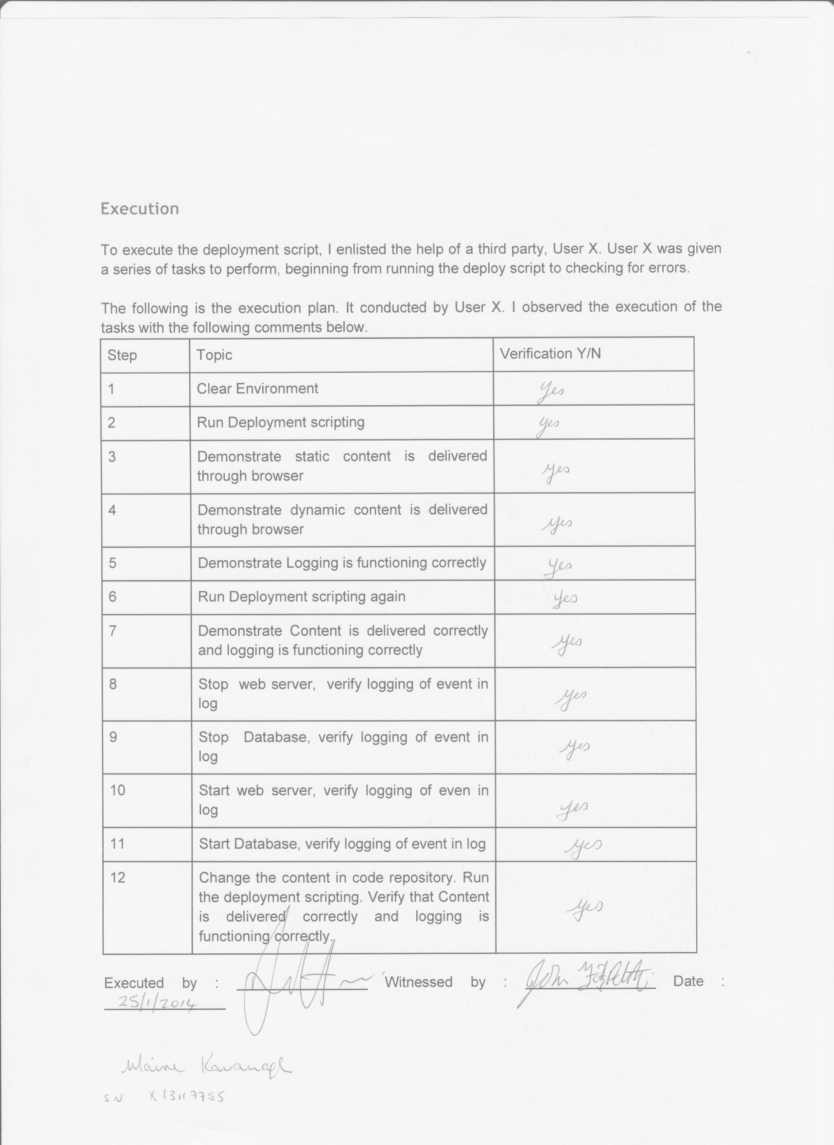

For step 1 the report generated shows the following final lines – which shows the database is up and running with the first record written in.

(Reading database ... 72611 files and directories currently installed.)
Unpacking mysql-client (from .../mysql-client_5.5.35-0ubuntu0.12.04.1_all.deb) ...
Selecting previously unselected package mysql-server.
Unpacking mysql-server (from .../mysql-server_5.5.35-0ubuntu0.12.04.1_all.deb) ...
Setting up mysql-client (5.5.35-0ubuntu0.12.04.1) ...
Setting up mysql-server (5.5.35-0ubuntu0.12.04.1) ...
Cloning into 'NCIRL'...
* Starting web server apache2
...done.
Rather than invoking init scripts through /etc/init.d, use the service(8)
utility, e.g. service mysql start

Since the script you are attempting to invoke has been converted to an
Upstart job, you may also use the start(8) utility, e.g. start mysql
mysql start/running, process 6426
name address
Maire Kavanagh NCIRL Mayor Street

For step 2 the report generated is
webpackage/
webpackage/script1.plx
webpackage/script2.plx
webpackage/form.htm
webpackage/index.htm
ae07a9ad0ae450e742def64e42980e78 not equal to 352e19c4df591f85b2ed5afe33b869b3
webpackage/
webpackage/script1.plx
webpackage/script2.plx
webpackage/form.htm
webpackage/index.htm
webpackage/
webpackage/script1.plx
webpackage/script2.plx
webpackage/form.htm
webpackage/index.htm
webpackage/
webpackage/script1.plx
webpackage/script2.plx
webpackage/form.htm
webpackage/index.htm
webpackage/
webpackage/script1.plx
webpackage/script2.plx
webpackage/form.htm
webpackage/index.htm
webpackage/
webpackage/script1.plx
webpackage/script2.plx
webpackage/form.htm
webpackage/index.htm
webpackage/
webpackage/script1.plx
webpackage/script2.plx
webpackage/form.htm
webpackage/index.htm
webpackage/
webpackage/script1.plx
webpackage/script2.plx
webpackage/form.htm
webpackage/index.htm

Screenshot for step 3 – static content
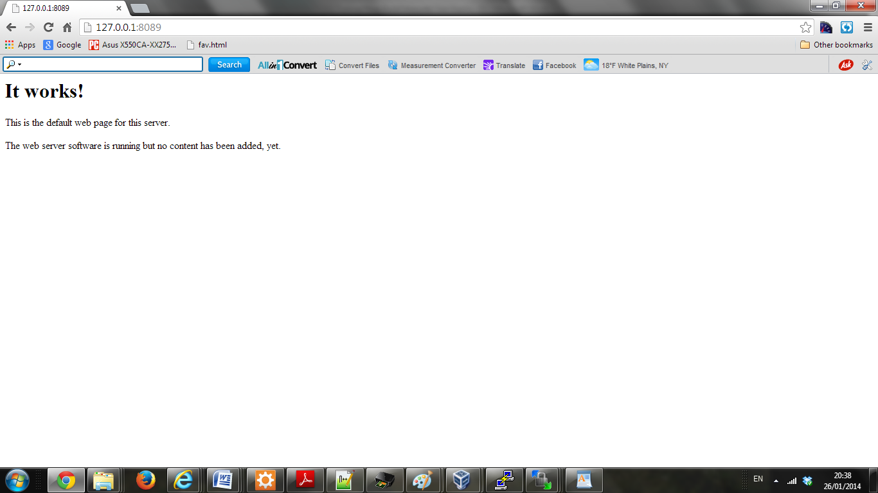

Screenshot for step 4 – dynamic content

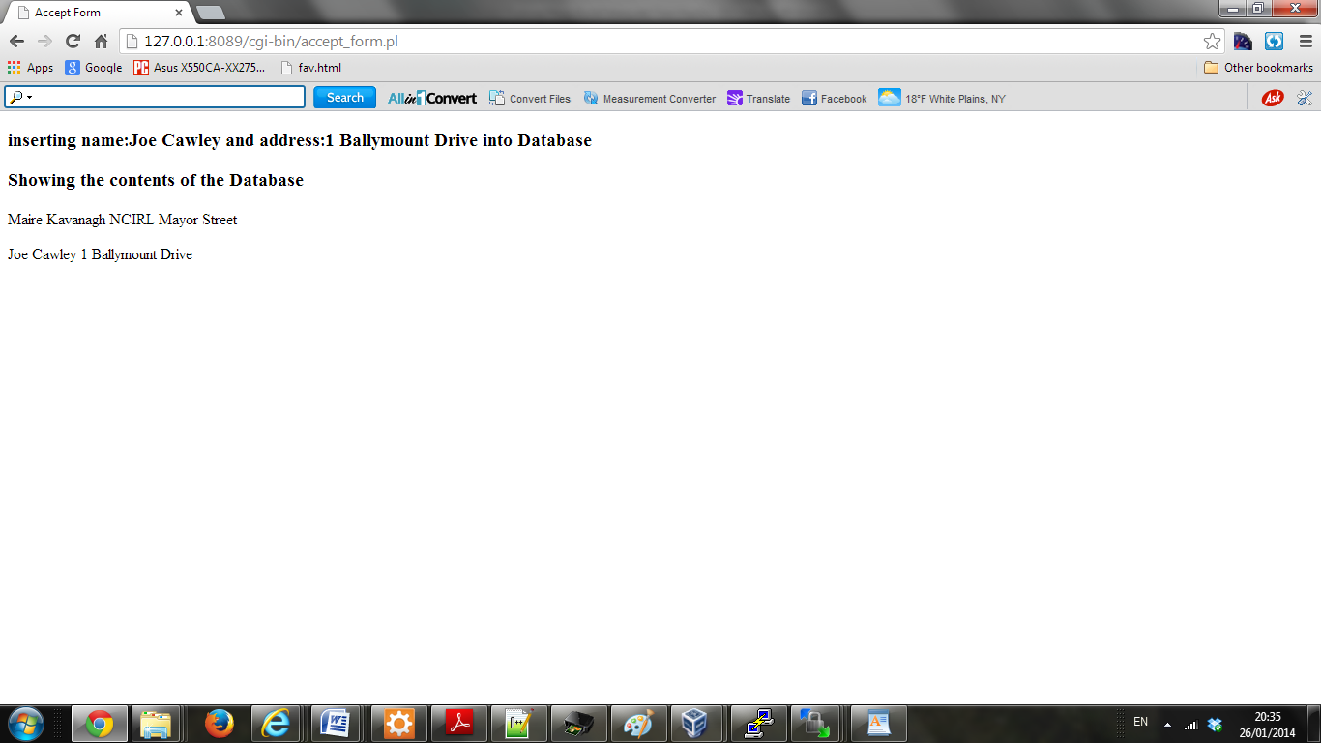

Logging for steps 8-11
Mysql process is Running
Mysql is Listening
Mysql is Listening at Date/Time --> 2014/01/24-17:18
Remote Mysql TCP port is up
1
Mysql process is Running
Mysql is Listening
Mysql is Listening at Date/Time --> 2014/01/24-17:19
Remote Mysql TCP port is up
1
Mysql process is Running
Mysql is Listening
Mysql is Listening at Date/Time --> 2014/01/24-17:20
Remote Mysql TCP port is up
Mysql process is not Running
Mysql is not Listening
Remote Mysql TCP port is down
Mysql process is not Running
Mysql is not Listening
Remote Mysql TCP port is down
Mysql process is Running
Mysql is not Listening
Remote Mysql TCP port is down
Mysql process is Running
Mysql is Listening
Mysql is Listening at Date/Time --> 2014/01/24-17:24
Remote Mysql TCP port is up

Screenshot for step 12 - added content

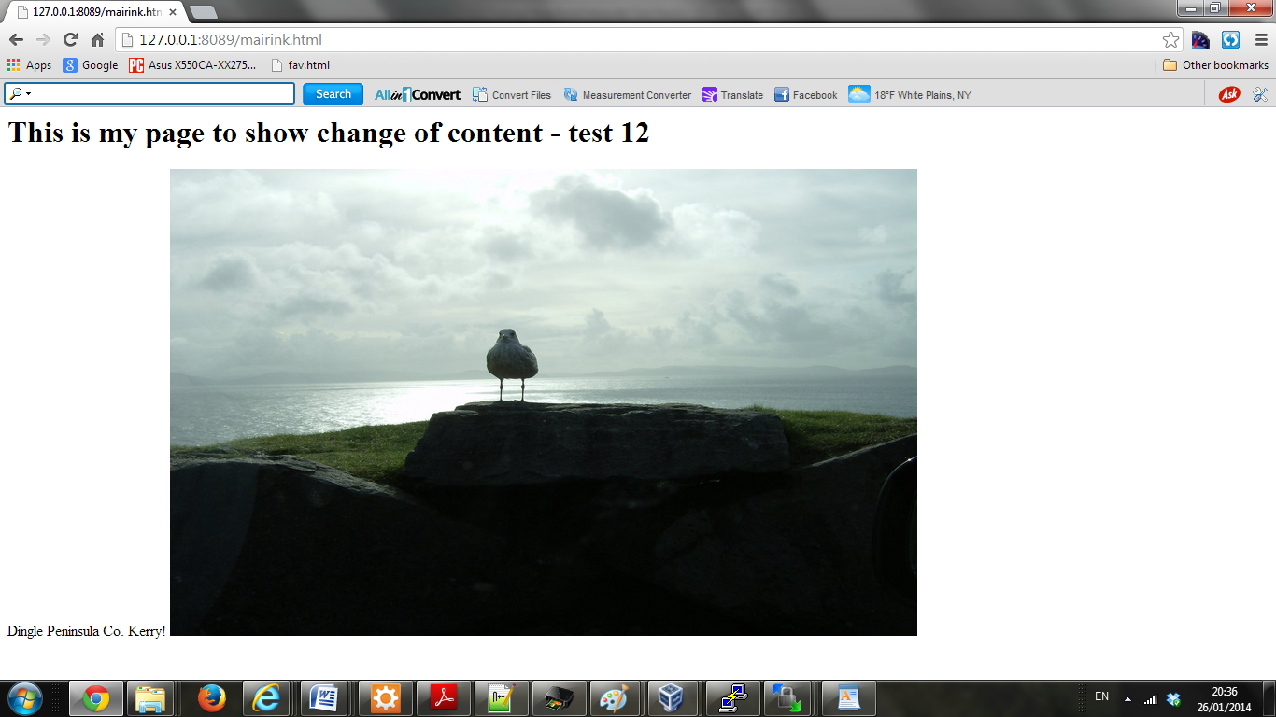

Summary and Conclusions
While the project is far from complete at this stage, the structure is now in place to put carry out some of the key tasks in the deployment process. Appendix B shows how the elements fit in with ITIL.

A github account set up for the deployment purpose –
This is a repository into code that has been released and signed off by the project team.
There is a Build Integrate Test and Deploy script set up, into which additional test scripts can be added.
There is a Clean Full Deploy script which will remove the dependencies such as Apache2 and MySql and reinstall them to ensure a clean environment before running the deployment script.
Scripts for monitoring these dependencies have been implemented, with crontab implemented so that there are log files recording the status.
A script for emailing the Administrator should the Apache server go down has been provided.
A script to back up the database has been provided.

Further work is required to add to the unit test scripts to gain additional core test coverage and to group unit tests to get a better level of Integration testing.

The System/User Acceptance tests need to be completed to provide full test coverage of all functionality and performance. There is a range of System Monitoring commands that can provide information on memory usage, CPU up time etc. so that should there be any resource issues these can be identified before they adversely affect the system running or even worse- cause a system crash.

From a security viewpoint, public key cryptography could be used in place of SSH to meet best practice. This allows a user to encrypt using their private key and only users with a copy of their public key can decipher the contents. There is an overhead though with this level of encryption. An alternative might be to do sessions with a simple encryption key and only the key is securely transmitted to the receiving party. Since the sessions are short, it is not likely that the key will be deciphered in time for any malicious user to interfere with the content.

References
Martin R. 2012 Agile Software Development First Edition Pearson Education New Jersey
Jalote, P. 2005 An Integrated Approach to Software Engineering Third Springer New York

Appendix A : Development Processes – Waterfall and Agile
The V model is similar to the waterfall method which has the following advantages:
- It is easy to understand and execute, and is logical and intuitive.
- At the end of each phase there is a formal review and an orderly release to the next stage. This facilitates formal controls and generally results in higher quality level.
- Many problems can be identified earlier in the process, by giving considered review of all aspects of the project- budgetary, technical, performance and compatibility with the hardware platform.
The major disadvantages of this process model is that
- it does not reflect reality where requirements often change over the duration of the project
- prototypes arrive late while customers want to see early prototypes both to satisfy themselves that it meets their requirements and to measure progress to gain confidence that the project is on course to be completed on time.
- in the design phase unanticipated problems can arise, leading to a need to change the requirements specification

Agile has the following advantages:
- It allows development to start even if the final requirements are not known.
- Resources put into planning concentrated on the short term – means minimal wastage in planning for later stages where the requirements may be unclear.
- It can accommodate changes since only the short term activities are fixed in the plan.
- Regular quick deliveries of working software are provided
- Feedback on software elements is delivered rapidly
Disadvantages
- Overhead associated with the planning of each iteration
- Cost may increase if work done is revised in later iterations
- Program structure may suffer as elements are constantly being added. If they were planned up front a more appropriate structure might have been selected.

Appendix B
ITIL – how the project elements fit in…
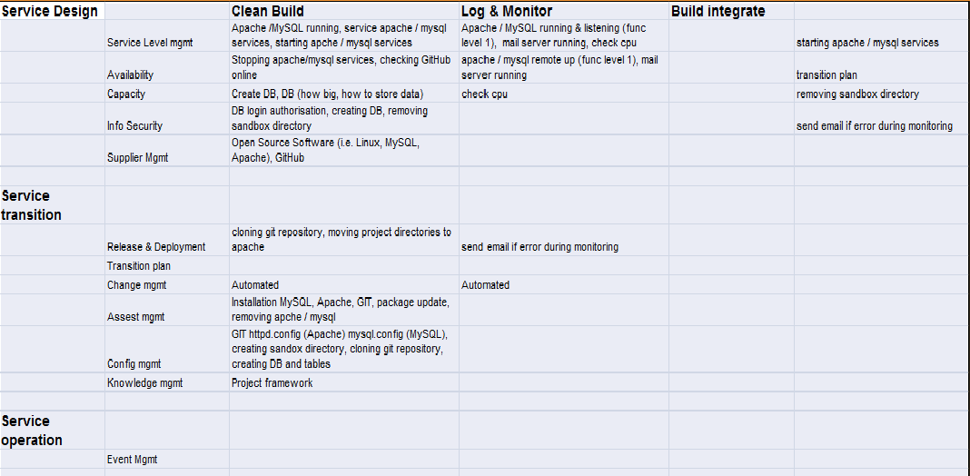

Appendix C – Alert email to Adminstrator
Below is an earlier record of the email to advise of an issue with Apache.
Since then for security protection reasons the code is modified so that it does not have the correct password for this email account. So this test cannot be re-run with the submitted code.
The printout was shown to the Tester as part of the implementation of the execution plan.
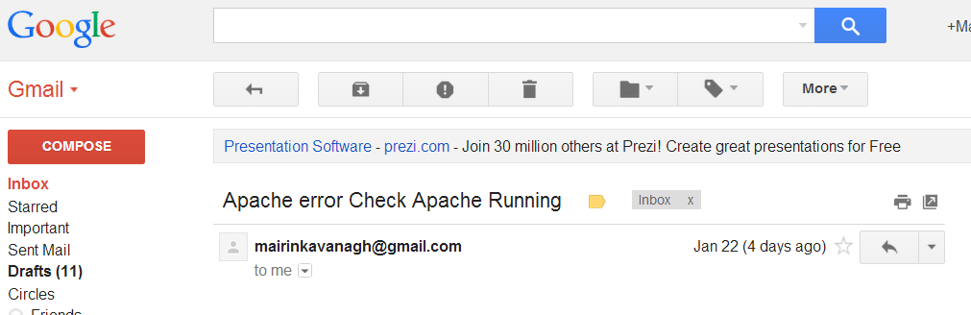

Ruby.mail code
require 'net/smtp' # ruby gem required
smtp = Net::SMTP.new 'smtp.gmail.com', 587
smtp.enable_starttls
emailServer = "smtp.gmail.com" # define server
serverPort = 25
passWord="********"# BLANKED OUT AFTER TEST
userName= "mairinkavanagh@gmail.com"
domain="gmail.com" # pass name to send it to
fm= "mairinkavanagh@gmail.com "
to = ARGV[0] –# take in the first parameter on the command line – the intended recipient
sendMsg = <<END_OF_MESSAGE
From: mairinkavanagh@gmail.com
To: #{ARGV[0]}
Subject: #{ARGV[1]} # take in the second parameter on the command line – the mail subject

#{ARGV[2]} # show the third parameter on the command line – the message
END_OF_MESSAGE
# send mail
begin
smtp = Net::SMTP.new('smtp.gmail.com', 587 )
smtp.enable_starttls
smtp.start(domain, userName, passWord, :login) do |smtp|
smtp.send_message sendMsg, fm, to
end
end

Appendix D - Logging
Extracts from logging file log.log showing MySQL and Apache stopping and starting:
Mysql process is Running At Date/Time -> 2014/01/24-13:28
Mysql process is Running At Date/Time -> 2014/01/24-13:29
Mysql process is Running At Date/Time -> 2014/01/24-13:30
MYsQL stopped at 2014/01/24-13:30
MySql restarted at 2014/01/24-13:30
Mysql process is Running At Date/Time -> 2014/01/24-13:31
MYsQL stopped at 2014/01/24-13:31
MySql restarted at 2014/01/24-13:33
Apache restarted at 2014/01/24-13:33
Mysql process is Running At Date/Time -> 2014/01/24-13:34
Apache stopped at 2014/01/24-13:34
Apache restarted at 2014/01/24-13:34
Mysql process is Running At Date/Time -> 2014/01/24-13:35
Mysql process is Running At Date/Time -> 2014/01/24-13:36
Apache stopped at 2014/01/24-13:36
Apache restarted at 2014/01/24-13:36
Mysql process is Running At Date/Time -> 2014/01/24-13:37
Mysql process is Running At Date/Time -> 2014/01/24-13:38
Mysql process is Running At Date/Time -> 2014/01/24-13:39
Mysql process is Running At Date/Time -> 2014/01/24-13:40

Mysql process is Running At Date/Time -> 2014/01/24-13:41

Appendix E – Database Back-up
System administrators are encouraged to make regular backups.
A script has been prepared for this – dbbackup.sh.
It contains the following code:
mysqldump -u 'dbtestuser' -'pdbpassword' 'dbtest' > 'backupdb.sql'

A back up was done on 24/10/2014.
-- MySQL dump 10.13 Distrib 5.5.34, for debian-linux-gnu (i686)
--
-- Host: localhost Database: dbtest
-- ------------------------------------------------------
-- Server version 5.5.34-0ubuntu0.12.04.1

/*!40101 SET @OLD_CHARACTER_SET_CLIENT=@@CHARACTER_SET_CLIENT */;
/*!40101 SET @OLD_CHARACTER_SET_RESULTS=@@CHARACTER_SET_RESULTS */;
/*!40101 SET @OLD_COLLATION_CONNECTION=@@COLLATION_CONNECTION */;
/*!40101 SET NAMES utf8 */;
/*!40103 SET @OLD_TIME_ZONE=@@TIME_ZONE */;
/*!40103 SET TIME_ZONE='+00:00' */;
/*!40014 SET @OLD_UNIQUE_CHECKS=@@UNIQUE_CHECKS, UNIQUE_CHECKS=0 */;
/*!40014 SET @OLD_FOREIGN_KEY_CHECKS=@@FOREIGN_KEY_CHECKS, FOREIGN_KEY_CHECKS=0 */;
/*!40101 SET @OLD_SQL_MODE=@@SQL_MODE, SQL_MODE='NO_AUTO_VALUE_ON_ZERO' */;
/*!40111 SET @OLD_SQL_NOTES=@@SQL_NOTES, SQL_NOTES=0 */;

--
-- Table structure for table `custdetails`
--

DROP TABLE IF EXISTS `custdetails`;
/*!40101 SET @saved_cs_client = @@character_set_client */;
/*!40101 SET character_set_client = utf8 */;
CREATE TABLE `custdetails` (
`name` varchar(30) NOT NULL DEFAULT '',
`address` varchar(30) NOT NULL DEFAULT ''
) ENGINE=InnoDB DEFAULT CHARSET=latin1;
/*!40101 SET character_set_client = @saved_cs_client */;

--
-- Dumping data for table `custdetails`
--

LOCK TABLES `custdetails` WRITE;
/*!40000 ALTER TABLE `custdetails` DISABLE KEYS */;
INSERT INTO `custdetails` VALUES ('Maire Kavanagh','NCIRL Mayor Street'),('Ann Smith','Main Street Dublin 3'),('Fran Baker','1 Chapel Street'),('Fran Baker','1 Chapel Street'),('Tom Finn','1 Church Street');
/*!40000 ALTER TABLE `custdetails` ENABLE KEYS */;
UNLOCK TABLES;
/*!40103 SET TIME_ZONE=@OLD_TIME_ZONE */;

/*!40101 SET SQL_MODE=@OLD_SQL_MODE */;
/*!40014 SET FOREIGN_KEY_CHECKS=@OLD_FOREIGN_KEY_CHECKS */;
/*!40014 SET UNIQUE_CHECKS=@OLD_UNIQUE_CHECKS */;
/*!40101 SET CHARACTER_SET_CLIENT=@OLD_CHARACTER_SET_CLIENT */;
/*!40101 SET CHARACTER_SET_RESULTS=@OLD_CHARACTER_SET_RESULTS */;
/*!40101 SET COLLATION_CONNECTION=@OLD_COLLATION_CONNECTION */;
/*!40111 SET SQL_NOTES=@OLD_SQL_NOTES */;

-- Dump completed on 2014-01-24 20:54:58

Appendix F : Printout of rbitdmk.sh

#!/bin/bash
# Mairin Kavanagh NCIRL

cd /tmp
# in the tmp directory create a sandbox directory and give it a random name.
SANDBOX=sandbox_$RANDOM
mkdir $SANDBOX
cd $SANDBOX

# Set error counter to zero
ERRORCHECK=0

# make a directory called webpackage and create files to put in it.
# Make test webpackage
mkdir webpackage
touch webpackage/index.htm
touch webpackage/form.htm
touch webpackage/script1.plx
touch webpackage/script2.plx
#
# Make the process directories
mkdir build
mkdir integrate
mkdir test
mkdir deploy
#
# Make webpackage and move webpackage
#

#tar / zip up webpackage calling it webpackage_preBuild.tgz
tar -zcvf webpackage_preBuild.tgz webpackage

# Check if MD5sum of this file has changed
MD5SUM=$(md5sum webpackage_preBuild.tgz | cut -f 1 -d' ')
PREVMD5SUM=$(cat /tmp/md5sum)
FILECHANGE=0
# if MD5sum has changed proceed. If no change, do nothing and exit.
if [[ "$MD5SUM" != "$PREVMD5SUM" ]]
then
FILECHANGE=1
echo $MD5SUM not equal to $PREVMD5SUM
else
FILECHANGE=0
echo $MD5SUM equal to $PREVMD5SUM
fi
echo $MD5SUM > /tmp/md5sum
if [ $FILECHANGE -eq 0 ]
then
echo no change in files, doing nothing and exiting
exit
fi
# Proceding to move the webpackage to the Build directory.
# BUILD
mv webpackage_preBuild.tgz build
rm -rf webpackage
cd build
#unzip the tar folder moved in from the preBuild
tar -zxvf webpackage_preBuild.tgz
#
#tar / zip up webpackage calling it webpackage_preIntegrate.tgz
tar -zcvf webpackage_preIntegrate.tgz webpackage
ERRORCHECK=0
# INTEGRATE
mv webpackage_preIntegrate.tgz ../integrate
rm -rf webpackage
cd ../integrate
#
tar -zxvf webpackage_preIntegrate.tgz
###

tar -zcvf webpackage_preTest.tgz webpackage
# Set error counter to zero
ERRORCHECK=0
# TEST
mv webpackage_preTest.tgz ../test
rm -rf webpackage
cd ../test
#
tar -zxvf webpackage_preTest.tgz
###
#tar / zip up webpackage calling it webpackage_preIntegrate.tgz
tar -zcvf webpackage_preDeploy.tgz webpackage
# Set error counter to zero
ERRORCHECK=0
# DEPLOY
# if error free tar / zip up webpackage calling it webpackage_preDeploy.tgz
if [ $ERRORCHECK -eq 0 ]
then
mv webpackage_preDeploy.tgz ../deploy
rm -rf webpackage
cd ../deploy
#unzip the tar folder moved in from the preDeploy
tar -zxvf webpackage_preDeploy.tgz
fi
# The webpackage is now in the DEPLOY folder - where it is ready for use in production following final signoff.

Appendix G : Printout of rcfdmk.sh

#!/usr/bin/bash
# Mairin Kavanagh NCIRL Full Clean Deploy script

# Make a sandbox directory, randomise its name and print that name back to screen

SANDBOX=sandbox_$RANDOM
echo Using sandbox $SANDBOX
#
# Stop services so as to orderly wind down so that apache2 and
# mysql can be wiped and reinstalled from scratch.

/etc/init.d/apache2 stop
/etc/init.d/mysql stop
#
apt-get update
#
# uninstall apache2, then reinstall
#
apt-get -q -y remove apache2
apt-get -q -y install apache2
#
# uninstall mysql, then reinstall
#

apt-get -q -y remove mysql-server mysql-client
echo mysql-server mysql-server/root_password password password | debconf-set-selections
echo mysql-server mysql-server/root_password_again password password | debconf-set-selections
apt-get -q -y install mysql-server mysql-client
#
# Make a sandbox within the /tmp directory
cd /tmp
mkdir $SANDBOX
cd $SANDBOX/
#
# Take a copy of the contents of github which should contain the released files to be deployed.
#
git clone https://github.com/FSlyne/NCIRL.git

#Move into the directory of the cloned files and copy to the required locations.
cd NCIRL/
#
cp Apache/www/* /var/www/
cp Apache/cgi-bin/* /usr/lib/cgi-bin/

# Set the required read access to the contents of the directories /usr/lib/cgi-bin/*
chmod a+x /usr/lib/cgi-bin/*
#
# Start services
/etc/init.d/apache2 start
/etc/init.d/mysql start

#
# Append code to add content by creating a database called 'dbtest' and populating it with some data.
# Before doing this drop any existing table with that name.
#
cat <<FINISH | mysql -uroot -ppassword
drop database if exists dbtest;
CREATE DATABASE dbtest;
GRANT ALL PRIVILEGES ON dbtest.* TO dbtestuser@localhost IDENTIFIED BY 'dbpassword';
use dbtest;
drop table if exists custdetails;
create table if not exists custdetails (
name VARCHAR(30) NOT NULL DEFAULT '',
address VARCHAR(30) NOT NULL DEFAULT ''
);
insert into custdetails (name,address) values ('Maire Kavanagh','NCIRL Mayor Street'); select * from custdetails;
FINISH
#
# Remove the sandbox created in the /tmp directory
#
cd /tmp
rm -rf $SANDBOX

This page is intentionally left blank!

This page is intentionally left blank!

